List of Simulation Excel Files

*Elsa estimated scrap potential numbers based on the possible improvement we can get in the near-ish future, and these numbers were used to calculate corresponding technical efficiency and collection rate numbers in the Opportunity.xlsx spreadsheet, where technical efficiencies are already without much room for improvement, according to experts in the field, so I primarily change collection rates as a means of changing the scrap potential, which is synonymous with the scrap supply shock*

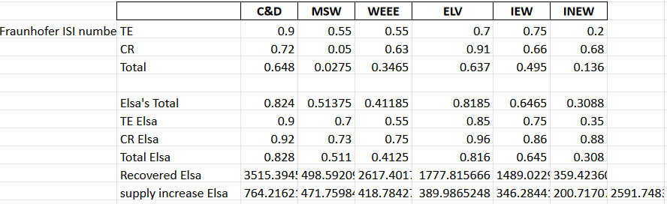

*Above, the 2591 value is our baseline scrap supply shock for the scenarios listed below.*

# Constant shock, varying duration - Initial:

Size of the shock is constant, but spread over varying number of years, with the first year matching 2*baseline/n (n = 1, 5, 10, 20 years), where 2*baseline=5200 kt as shown in John_1yrX2_scrap files below

* 00 Initial Linear Ramp Shocks/John_1yrX2_scrap
  + price John_1yrX2_scrap.xlsx, S&D John_1yrX2_scrap.xlsx, mine life John_1yrX2_scrap.xlsx
  + This is a one-year shock, X2 is for size of initial shock being twice the size of Elsa’s best-case potential improvements in the Opportunity.xlsx spreadsheet (actually adds 5423 kt)

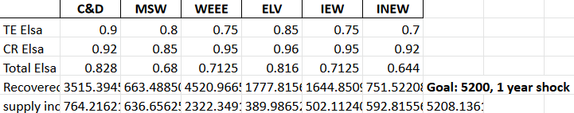

* 00 Initial Linear Ramp Shocks/constshockinit_5yr
  + 5-year shock that would add to 5200 if scrap supply remained constant (actually adds 5632 kt)

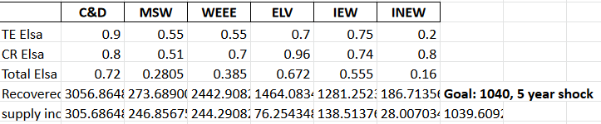

* 00 Initial Linear Ramp Shocks/constshockinit_10yr
  + 10-year shock that would add to 5200 if scrap supply remained constant (actually adds 6102 kt)

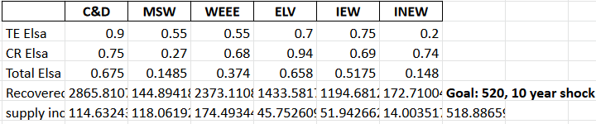

* 00 Initial Linear Ramp Shocks/constshockinit_20yr
  + 20-year shock that would add to 5200 if scrap supply remained constant (actually adds 7111 kt)

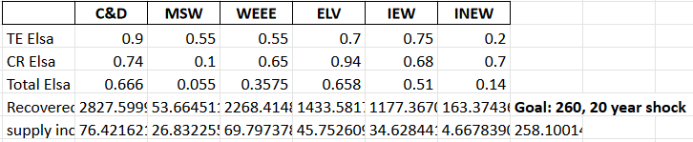

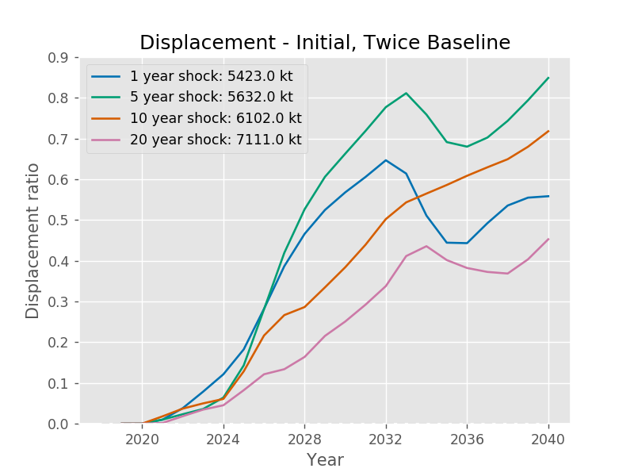

# Constant shock, varying duration – Total:

Size of the shock is constant, but spread over varying number of years, with the recovery rates iterated until the total scrap increase due to the shock is 5200 (baseline*2)

* 00 Initial Linear Ramp Shocks/constshocktot_5yr
  + 5-year shock that adds 5429 kt to scrap supply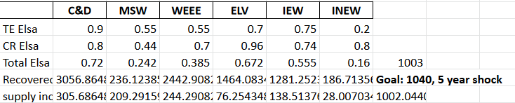
* 00 Initial Linear Ramp Shocks/constshocktot_10yr
  + 10-year shock that adds 5409 kt to scrap supply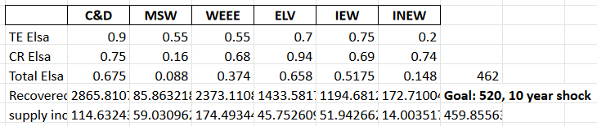
* 00 Initial Linear Ramp Shocks/constshocktot_20yr
  + 20-year shock that adds 5433 kt to scrap supply (how much is due to the shock and how much due to response?) 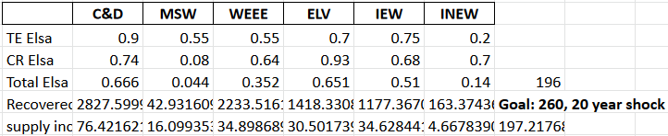

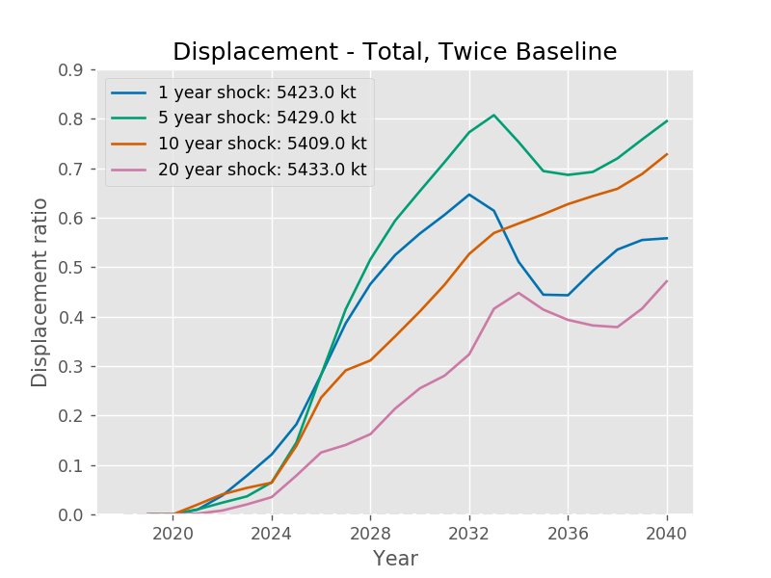

# Linear Shock Increase (100% of Base Shock), Varying Time Elapsed to Base Shock

1. Increasing the sorting efficiency (technical efficiency) and collection rate up to the base shock value calculated (~2600) in Opportunity.xlsx using np.linspace (linear)

2. Doing so over the course of 1 year, 5 years, 10 years, and 20 years

3. Going from Fraunhofer current (top section) to Elsa’s projected (lower section):

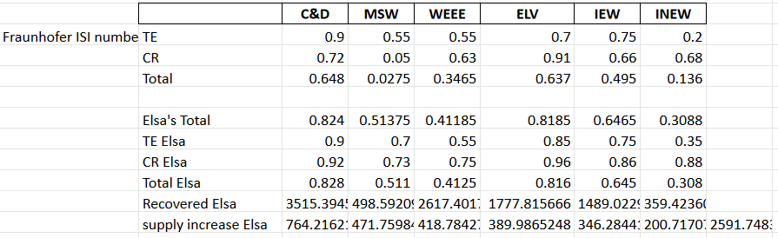

* 00 Initial Linear Ramp Shocks/linshock1yr, linshock1yr-sp2 (the others have this appendage as well, since needed to run again with the scrap spread constraint relaxed) – relaxing the constraint was not enough and it still hits it early – needed both TCRC (3000) and scrap spread (5000, sp2) upper constraints relaxed
* 00 Initial Linear Ramp Shocks/linshock5yr
* 00 Initial Linear Ramp Shocks/linshock10yr
* 00 Initial Linear Ramp Shocks/linshock20yr

**These figures are all with the scrap spread constraint relaxed**

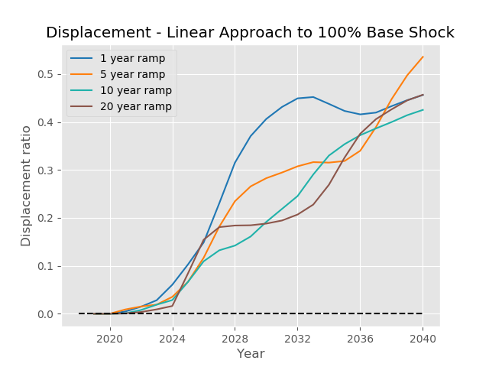

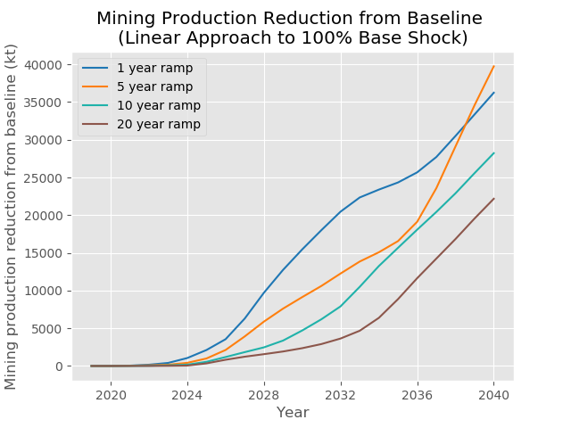 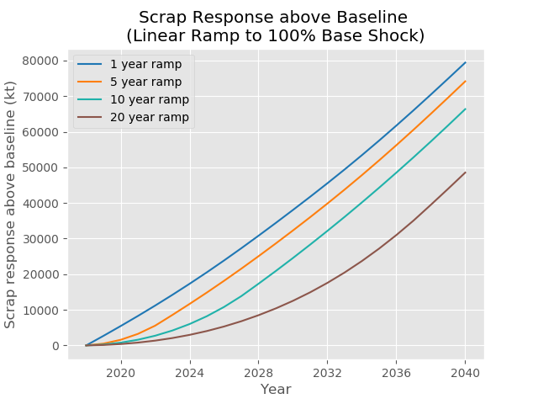

# Linear Shock Increase (20% of Base Shock), Varying Time Elapsed to Base Shock

1. Increasing the sorting efficiency (technical efficiency) and collection rate up to the base shock value calculated (~504 kt) in Opportunity.xlsx using np.linspace (linear)

2. Doing so over the course of 1 year, 5 years, 10 years, and 20 years

3. Going from Fraunhofer current (top section) to Elsa’s projected (lower section):

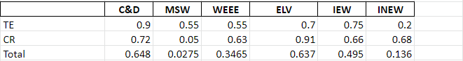

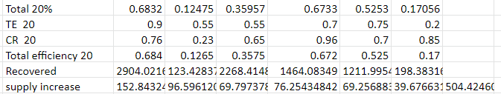

* 00 Initial Linear Ramp Shocks/linshock1yr20, linshock5yr20, linshock10yr20, linshock20yr20

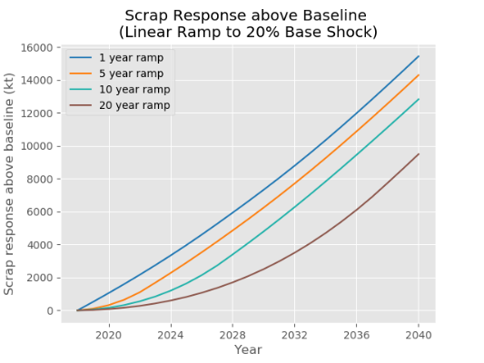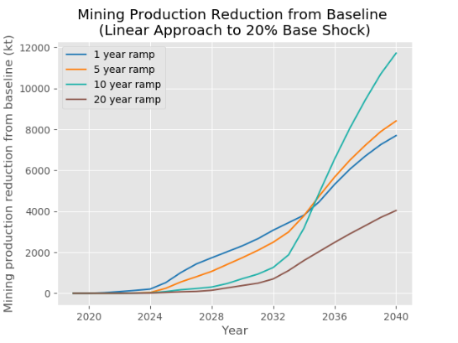

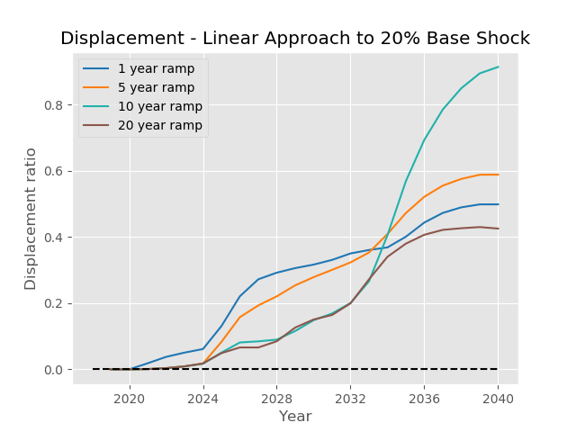

Actual code:

sort_eff_series=pd.DataFrame(np.array((list(sort_eff)*23)).reshape(23, 6), index=np.arange(2018, 2041), columns=sort_eff.index)

collect_rate_series=pd.DataFrame(np.array((list(collect_rate)*23)).reshape(23, 6), index=np.arange(2018, 2041), columns=collect_rate.index)

sort_eff_series.loc[2019:,'C&D':'INEW'] = [0.9,0.7,0.55,0.85,0.75,0.35]

collect_rate_series.loc[2019:,'C&D':'INEW']=[0.92,0.73,0.75,0.96,0.86,0.88]

# ^this is for one year, others used np.linspace to go to the same values over longer timeframe

sec_coef=0

sp2_sd_elas=0.0845

Correlations between No. 2 Spread and Cathode Price: corr() function

|  |  |  |  |  |
| --- | --- | --- | --- | --- |
|  | Tight Scrap Spread Constraint | | Relaxed Scrap Spread Constraint | |
|  | **Historical** | **Simulated** | **Historical** | **Simulated** |
| Original Data | 0.81 | 0.56 | 0.85 | 0.95 |
| First Difference | 0.85 | 0.09 | 0.81 | 0.89 |

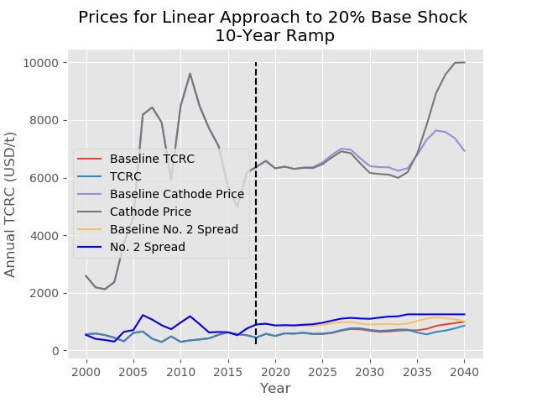

Prices for Linear Approach to 20% Base Shock

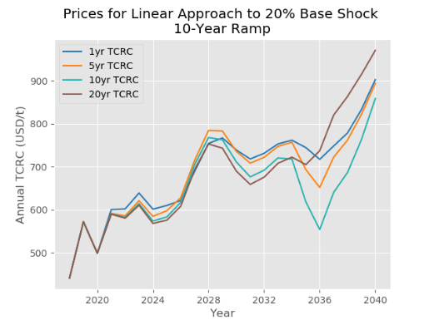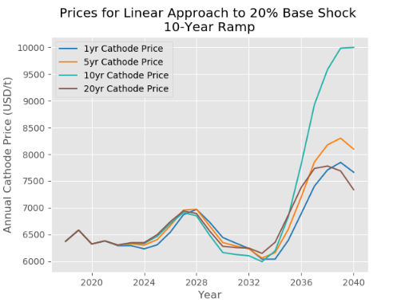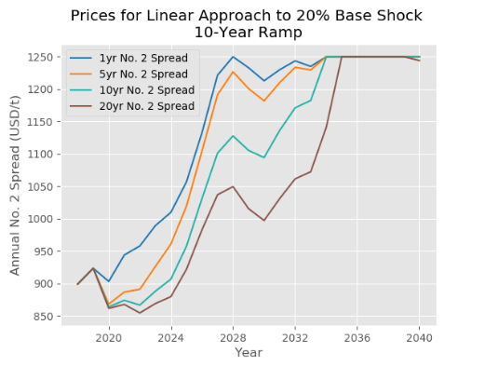

Run into limits on No. 2 Spread (1250), Cathode Price (10,000)

## Response with Relaxed Scrap Spread Constraint - saved as linshock1yr20-sp2, linshock5yr20-sp2, etc.

Relaxed TCRC upper constraint to 3000, scrap spread (sp2) to 5000

Prices for Linear Approach to 20% Base Shock, Relaxed Scrap Spread Constraint

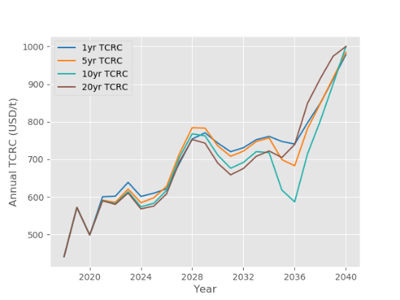 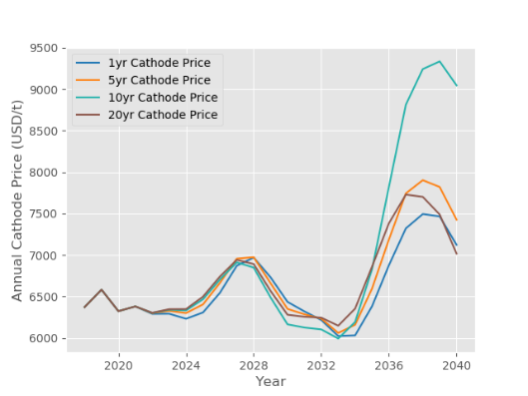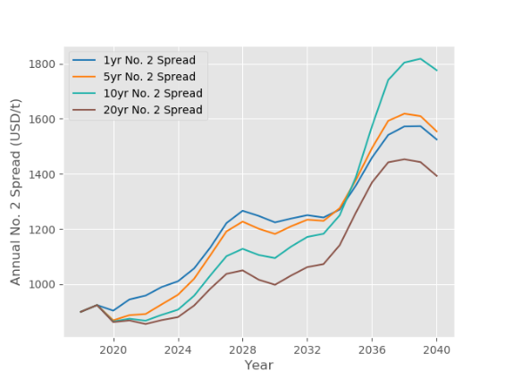

**Response with Scrap Spread (SP2) Constraint Relaxed**

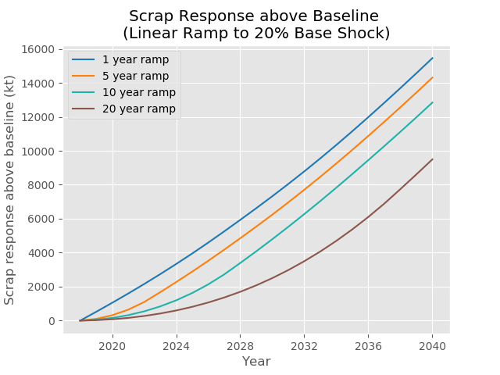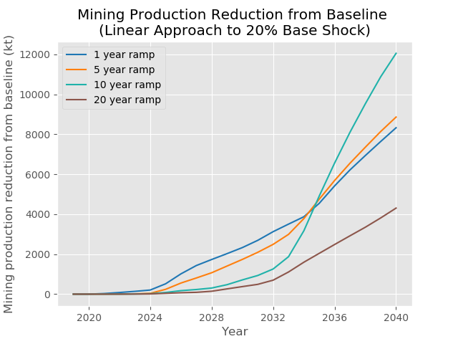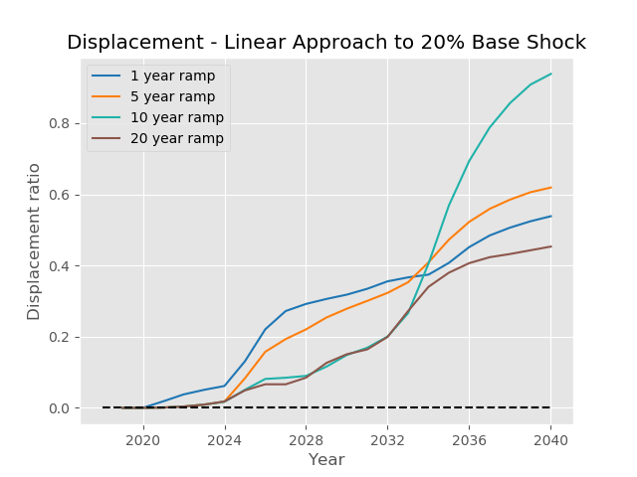

# Linear Shock Increase (50% of Base Shock), Varying Time Elapsed to Base Shock

1. Increasing the sorting efficiency (technical efficiency) and collection rate up to the base shock value calculated (~1298 kt) in Opportunity.xlsx using np.linspace (linear)

2. Doing so over the course of 1 year, 5 years, 10 years, and 20 years

3. Going from Fraunhofer current (top section) to Elsa’s projected (lower section):



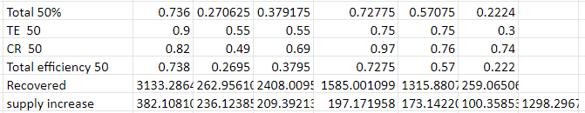

* 00 Initial Linear Ramp Shocks/linshock1yr50, linshock5yr50, linshock10yr50, linshock20yr50, linshock20yr50-sp2 (the others have this appendage as well, since needed to run again with the scrap spread constraint relaxed)

**These figures are all with the scrap spread constraint in place**

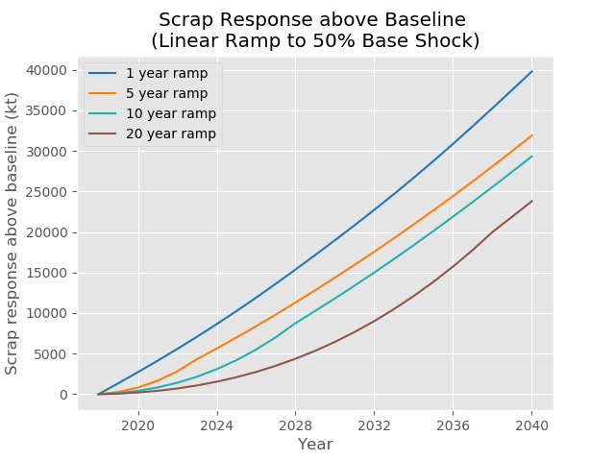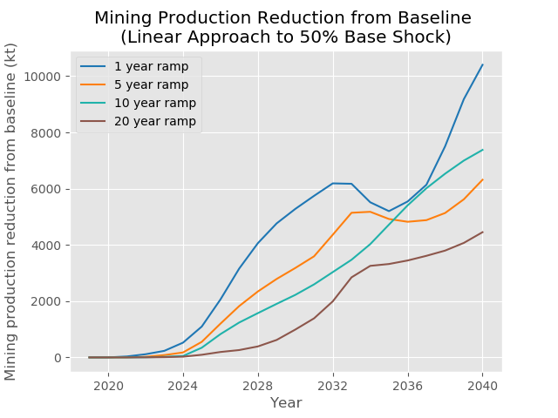

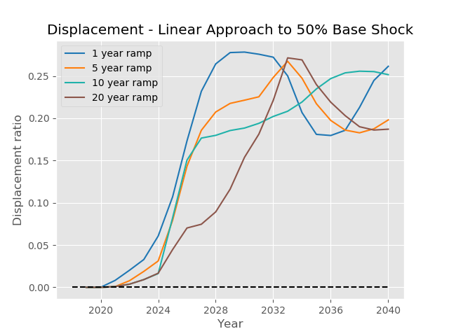

# Linear Shock Increase (10% of Base Shock), Varying Time Elapsed to Base Shock

1. Increasing the sorting efficiency (technical efficiency) and collection rate up to the base shock value calculated (~261 kt) in Opportunity.xlsx using np.linspace (linear)

2. Doing so over the course of 1 year, 5 years, 10 years, and 20 years

3. Going from Fraunhofer current (top section) to Elsa’s projected (lower section):



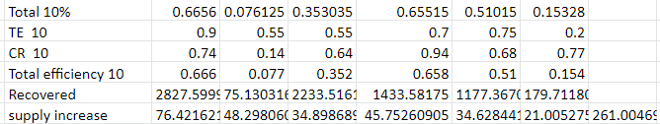

* 00 Initial Linear Ramp Shocks/linshock1yr10-sp2, linshock5yr10-sp2, linshock10yr10-sp2, linshock20yr10-sp2 (haven’t run it without the constraint relaxed)

These figures are all with the scrap spread constraint relaxed

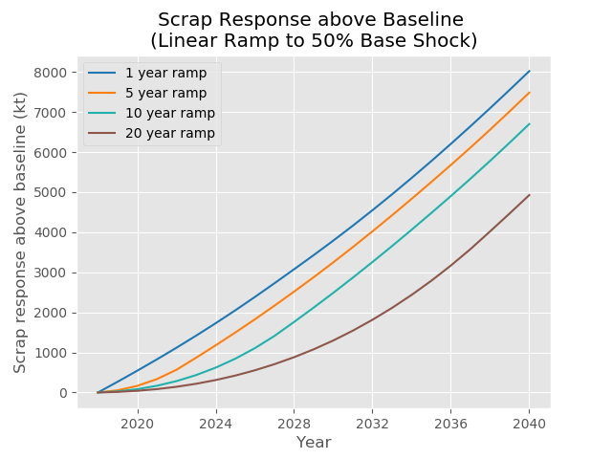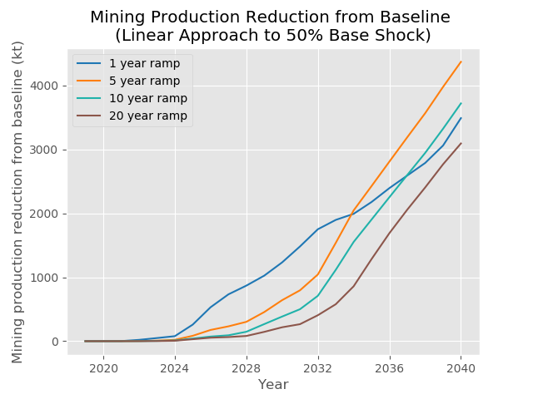

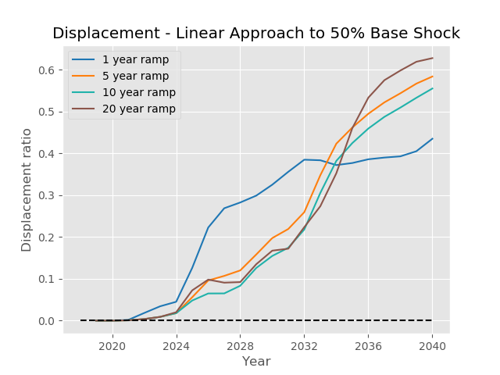

# Refinery Secondary Ratio High and Low, 100% Linear Shock

1. Multiplying the refinery secondary ratio elasticity to scrap spread and TCRC elasticities by 2 or 0.5

2. Increasing the sorting efficiency (technical efficiency) and collection rate up to the base shock value calculated (~2600 kt) in Opportunity.xlsx

3. Doing so over the course of 1 year, 5 years, 10 years, and 20 years

Actual code:

ref_hyper_param.loc['sec ratio SP2 elas','Value']*=2

ref_hyper_param.loc['sec ratio TCRC elas','Value']*=2

Saved as: 01 Linear Ramp + SP2E/____ sp2hi_baseline, sp2hi1yr… sp2hi20yr, sp2lo_baseline, etc.

# Refinery Secondary Ratio Elasticity High and Low, 20% Linear Shock

Decided to do the sensitivity studies using the linear shock value producing the highest displacement since it is most justifiable / possibly interesting

1. Multiplying the refinery secondary ratio elasticity to scrap spread and TCRC elasticities by 2 or 0.5

2. Increasing the sorting efficiency (technical efficiency) and collection rate up to 20% of the base shock value calculated (~504 kt) in Opportunity.xlsx

3. Doing so over the course of 1 year, 5 years, 10 years, and 20 years

*Actual code*: same as 100% Linear shock version above, different values for collection rate / technical efficiency though

*Saved as*: 01 Linear Ramp + SP2E/____ sp2hi_baseline, sp2hi1yr20… sp2hi20yr20, sp2lo_baseline, sp2lo10yr20… (20 comes at end to signify 20% shock)

# Mine Production Elasticity

1. Multiplying the mine production elasticity (capacity utilization (CU) short run elasticity to TCM) by 2 or 0.5

2. Increasing the sorting efficiency (technical efficiency) and collection rate up to 20% of the base shock value calculated (~504 kt) in Opportunity.xlsx

3. Doing so over the course of 1 year, 5 years, 10 years, and 20 years

*Actual code*: pri_hyper_param.loc['Production elasticity','Value']*=2 or 0.5

*Saved as*: 02 Linear Ramp + MPE/____ mpehi_baseline, mpehi_1yr20, mpelo_baseline, mpelo_20yr20 (20 at end indicates 20% shock, each of the 4-year ramps is reached in 1yr, 5yr, 10yr, 20yr)

# Scrap Supply-Demand Elasticity, 20% Linear Ramp

1. Multiplying the scrap supply & demand elasticity (elasticity of scrap spread to scrap S&D effect) by 2 or 0.5

2. Increasing the sorting efficiency (technical efficiency) and collection rate up to 20% of the base shock value calculated (~504 kt) in Opportunity.xlsx

3. Doing so over the course of 1 year, 5 years, 10 years, and 20 years

*Actual code*: sp2_sd_elas*=2 or 0.5

*Saved as*: 03 Linear Ramp + SSDE/_____ ssdehi_baseline, ssdehi1yr20, ssdelo10yr20 (20 at end indicates 20% shock, each of the 4-year ramps is reached in 1yr, 5yr, 10yr, 20yr)

# Demand Elasticity, 20% Linear Ramp

1. Multiplying the copper demand elasticity to cathode price by 2 or 4, since this elasticity was considered a little low by Xinkai and Karan, and going lower seemed unrealistic

2. Increasing the sorting efficiency (technical efficiency) and collection rate up to 20% of the base shock value calculated (~504 kt) in Opportunity.xlsx

3. Doing so over the course of 1 year, 5 years, 10 years, and 20 years

*Actual code*: elas_sec_reg.loc['Construction':'ROW','Elasticity mean']*=4 or 2

*Saved as*: 04 Linear Ramp + DE/______ 200de_baseline, 400de_baseline, 200de1yr20, 400de5yr20 (20 at end indicates 20% shock, each of the 4-year ramps is reached in the 1yr, 5yr, 10yr, 20yr variations)